**Unit 4 Assignment 4**

**Basic Program: DataGridView**

**Code:**

**using System;**

**using System.Collections.Generic;**

**using System.ComponentModel;**

**using System.Data;**

**using System.Drawing;**

**using System.Linq;**

**using System.Text;**

**using System.Windows.Forms;**

**using System.Data.SqlClient;**

**namespace Basic**

**{**

**public partial class Form1 : Form**

**{**

**public Form1()**

**{**

**InitializeComponent();**

**}**

**private void button1_Click(object sender, EventArgs e)**

**{**

**SqlConnection con = new SqlConnection(@"Data Source=.\SQLEXPRESS;AttachDbFilename=C:\Users\janki\OneDrive\Documents\Employee1.mdf;Integrated Security=True;Connect Timeout=30;User Instance=True");**

**con.Open();**

**DataTable data = new DataTable();**

**SqlDataAdapter da = new SqlDataAdapter("select * from Employee1", con);**

**da.Fill(data);**

**dataGridView1.DataSource = data;**

**}**

**}**

**}**

**Output:**

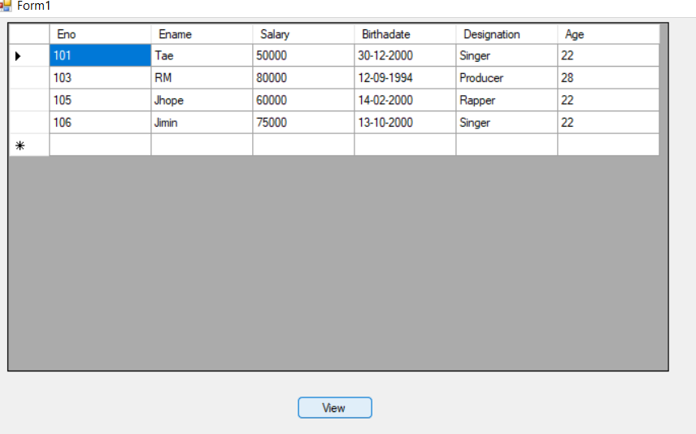

**Pro 1: write a Program to develop a Database Application with ADO.NET with Record Navigation and Add, Delete, Save, and Update Facility for Books table(Book Id, Book Name, Qty, Unit Price, Total Price ).**

**Code:**

**using System;**

**using System.Collections.Generic;**

**using System.ComponentModel;**

**using System.Data;**

**using System.Drawing;**

**using System.Linq;**

**using System.Text;**

**using System.Windows.Forms;**

**using System.Data.SqlClient;**

**namespace U4P1**

**{**

**public partial class Form1 : Form**

**{**

**SqlConnection con = new SqlConnection(@"Data Source=.\SQLEXPRESS;AttachDbFilename=C:\Users\janki\OneDrive\Documents\Book.mdf;Integrated Security=True;Connect Timeout=30;User Instance=True");**

**SqlCommand cmd;**

**public Form1()**

**{**

**InitializeComponent();**

**}**

**private void button1_Click(object sender, EventArgs e)**

**{**

**con.Open();**

**cmd = new SqlCommand("insert into Book values('" + textBox1.Text + "','" + textBox2.Text + "','" + textBox3.Text + "','" + textBox4.Text + "','" + textBox5.Text + "')", con);**

**cmd.ExecuteNonQuery();**

**MessageBox.Show("Insert Data Successfully");**

**con.Close();**

**}**

**private void button2_Click(object sender, EventArgs e)**

**{**

**con.Open();**

**cmd = new SqlCommand("delete from Book where Id=" + textBox1.Text, con);**

**cmd.ExecuteNonQuery();**

**con.Close();**

**}**

**private void button3_Click(object sender, EventArgs e)**

**{**

**textBox1.Text = textBox2.Text = textBox3.Text = textBox4.Text = textBox5.Text = "";**

**}**

**private void button4_Click(object sender, EventArgs e)**

**{**

**con.Open();**

**cmd = new SqlCommand("update Book set Name='"+textBox2.Text+"',Qty='"+textBox3.Text+"',UnitPrice='"+textBox4.Text+"',TotalPrice='"+textBox5.Text+"' where ID= "+Convert.ToInt16(textBox1.Text)+" ",con);**

**cmd.ExecuteNonQuery();**

**con.Close();**

**}**

**}**

**}**

**Output**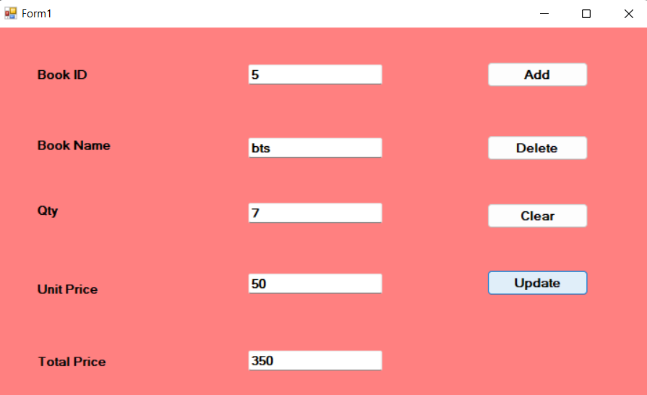

**Table:**

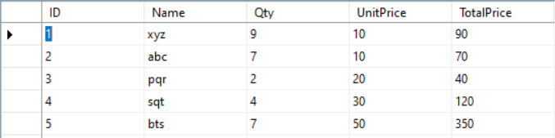

**Pro 2: Create a login form which will validate user name and password from the database. On Validation show MDI form. Show appropriate message if user name and password is incorrect.**

**Code:**

**using System;**

**using System.Collections.Generic;**

**using System.ComponentModel;**

**using System.Data;**

**using System.Drawing;**

**using System.Linq;**

**using System.Text;**

**using System.Windows.Forms;**

**using System.Data.SqlClient;**

**namespace U4P2**

**{**

**public partial class Form1 : Form**

**{**

**public Form1()**

**{**

**InitializeComponent();**

**}**

**private void button1_Click(object sender, EventArgs e)**

**{**

**Application.Exit();**

**}**

**private void button2_Click(object sender, EventArgs e)**

**{**

**SqlConnection con = new SqlConnection(@"Data Source=.\SQLEXPRESS;AttachDbFilename=C:\Users\janki\OneDrive\Documents\Login.mdf;Integrated Security=True;Connect Timeout=30;User Instance=True");**

**con.Open();**

**SqlCommand cmd = new SqlCommand("select * from LoginTable where loginId='"+textBox1.Text+"' AND pword='"+textBox2.Text+"'",con);**

**SqlDataReader dr = cmd.ExecuteReader();**

**if (dr.Read())**

**{**

**Form f2 = new Form2();**

**f2.Show();**

**}**

**else**

**{**

**MessageBox.Show("LoginId or Password is not correct");**

**}**

**}**

**}**

**}**

**OUTPUT:**

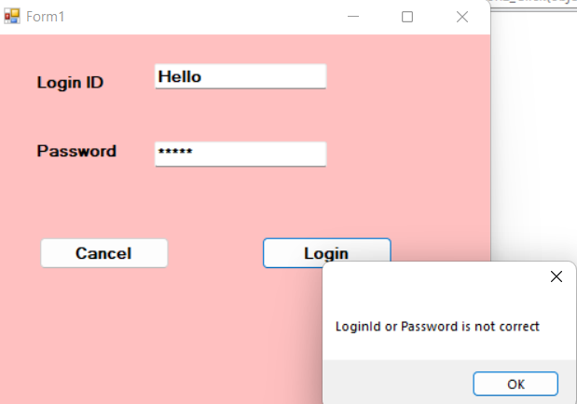

**Table:**

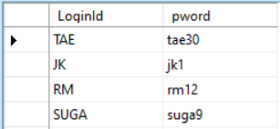

**Pro 3: Create Table State(StateCode,StateName) and City(CityCode,CityName,StateCode). Design a form which will list all the ComboBox. After selection of the stateName , another ComboBox should display all the cities which belong to the select by the user in the first ComboBox.**

**Code:**

**using System;**

**using System.Collections.Generic;**

**using System.ComponentModel;**

**using System.Data;**

**using System.Drawing;**

**using System.Linq;**

**using System.Text;**

**using System.Windows.Forms;**

**using System.Data.SqlClient;**

**namespace U4P3**

**{**

**public partial class Form1 : Form**

**{**

**SqlConnection con = new SqlConnection(@"Data Source=.\SQLEXPRESS;AttachDbFilename=C:\Users\janki\OneDrive\Documents\StateCity.mdf;Integrated Security=True;Connect Timeout=30;User Instance=True");**

**SqlCommand cmd;**

**public Form1()**

**{**

**InitializeComponent();**

**}**

**private void Form1_Load(object sender, EventArgs e)**

**{**

**con.Open();**

**cmd = new SqlCommand("select StateName from State",con);**

**SqlDataReader dr = cmd.ExecuteReader();**

**while(dr.Read())**

**{**

**comboBox1.Items.Add(dr[0]);**

**}**

**con.Close();**

**}**

**private void comboBox1_SelectedIndexChanged(object sender, EventArgs e)**

**{**

**con.Open();**

**//cmd.CommandText = "select StateCode from State where StateName='"+comboBox1.Text+"'";**

**cmd = new SqlCommand("select CityName from City where StateCode=(select StateCode from State where StateName='" + comboBox1.Text + "')", con);**

**SqlDataReader dr = cmd.ExecuteReader();**

**while(dr.Read())**

**{**

**comboBox2.Items.Add(dr[0]);**

**}**

**con.Close();**

**}**

**}**

**}**

**Table:**

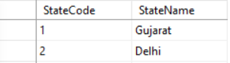

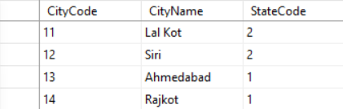

**Output:**

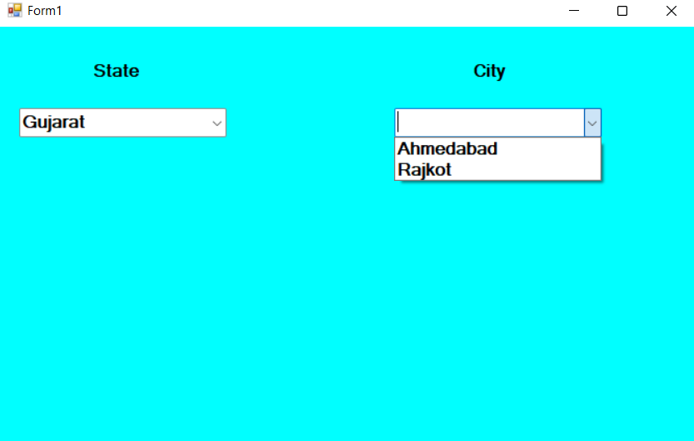

**Pro 4: Write a Program to create a table Emp with the following fields:**

**Field Name DataType**

**Eno Integer**

**Ename Varchar(20)**

**Salary Single**

**Birthdate Date**

**Designation Varchar(20)**

**Design a From which perform Select, Insert, Update and Delete operation on the table Emp. On Insert Eno has been generated automatically.**

**Code:**

**using System;**

**using System.Collections.Generic;**

**using System.ComponentModel;**

**using System.Data;**

**using System.Drawing;**

**using System.Linq;**

**using System.Text;**

**using System.Windows.Forms;**

**using System.Data.SqlClient;**

**namespace U4P4**

**{**

**public partial class Form1 : Form**

**{**

**SqlConnection con = new SqlConnection(@"Data Source=.\SQLEXPRESS;AttachDbFilename=C:\Users\janki\OneDrive\Documents\Employee1.mdf;Integrated Security=True;Connect Timeout=30;User Instance=True");**

**SqlCommand cmd;**

**SqlDataAdapter da;**

**DataTable data = new DataTable();**

**DataSet ds;**

**int pos;**

**public Form1()**

**{**

**InitializeComponent();**

**}**

**private void btnInsert_Click(object sender, EventArgs e)**

**{**

**con.Open();**

**cmd = new SqlCommand("insert into Employee1 values('"+textBox1.Text+"','"+textBox2.Text+"','"+textBox3.Text+"','"+textBox4.Text+"','"+textBox5.Text+"')",con);**

**cmd.ExecuteNonQuery();**

**MessageBox.Show("Successfully Insert");**

**con.Close();**

**}**

**private void btnSel_Click(object sender, EventArgs e)**

**{**

**cmd = new SqlCommand("select * from Employee1",con);**

**da = new SqlDataAdapter(cmd);**

**ds = new DataSet();**

**da.Fill(ds);**

**textBox1.DataBindings.Add("Text", ds.Tables[0], "Eno");**

**textBox2.DataBindings.Add("Text", ds.Tables[0], "Ename");**

**textBox3.DataBindings.Add("Text", ds.Tables[0], "Salary");**

**textBox4.DataBindings.Add("Text", ds.Tables[0], "Birthadate");**

**textBox5.DataBindings.Add("Text", ds.Tables[0], "Designation");**

**}**

**private void btnFirst_Click(object sender, EventArgs e)**

**{**

**//this.BindingContext[ds.Tables[0]].Position = 0;**

**pos = 0;**

**displaytext(pos);**

**}**

**private void btnPrev_Click(object sender, EventArgs e)**

**{**

**pos = pos - 1;**

**displaytext(pos);**

**//this.BindingContext[ds.Tables[0]].Position = this.BindingContext[ds.Tables[0]].Position -1;**

**}**

**private void btnNext_Click(object sender, EventArgs e)**

**{**

**pos = pos + 1;**

**displaytext(pos);**

**//this.BindingContext[ds.Tables[0]].Position = this.BindingContext[ds.Tables[0]].Position + 1;**

**}**

**private void btnClr_Click(object sender, EventArgs e)**

**{**

**textBox1.Text = textBox2.Text = textBox3.Text = textBox4.Text = textBox5.Text = "";**

**}**

**private void btnUpdate_Click(object sender, EventArgs e)**

**{**

**SqlConnection con = new SqlConnection(@"Data Source=.\SQLEXPRESS;AttachDbFilename=C:\Users\janki\OneDrive\Documents\Employee1.mdf;Integrated Security=True;Connect Timeout=30;User Instance=True");**

**con.Open();**

**SqlCommand cmd = new SqlCommand("update Employee1 set Ename= '" + textBox2.Text + "', Salary= '" + textBox3.Text + "' ,Birthadate= '"+textBox4.Text+"' ,Designation='" + textBox5.Text + "' where Eno= " + Convert.ToInt16(textBox1.Text) + " ", con);**

**cmd.ExecuteNonQuery();**

**con.Close();**

**}**

**private void btnDel_Click(object sender, EventArgs e)**

**{**

**con.Open();**

**SqlCommand cmd = new SqlCommand("delete from Employee1 where Eno=" +textBox1.Text,con);**

**cmd.ExecuteNonQuery();**

**MessageBox.Show("delete successfully");**

**con.Close();**

**}**

**private void Form1_Load(object sender, EventArgs e)**

**{**

**da = new SqlDataAdapter("select * from Employee1",con);**

**da.Fill(data);**

**pos = 0;**

**displaytext(pos);**

**}**

**public void displaytext(int rowno)**

**{**

**textBox1.Text = data.Rows[rowno][0].ToString();**

**textBox2.Text = data.Rows[rowno][1].ToString();**

**textBox3.Text = data.Rows[rowno][2].ToString();**

**textBox4.Text = data.Rows[rowno][3].ToString();**

**textBox5.Text = data.Rows[rowno][4].ToString();**

**}**

**private void btnLast_Click(object sender, EventArgs e)**

**{**

**pos = data.Rows.Count - 1;**

**displaytext(pos);**

**}**

**}**

**}**

**Output:**

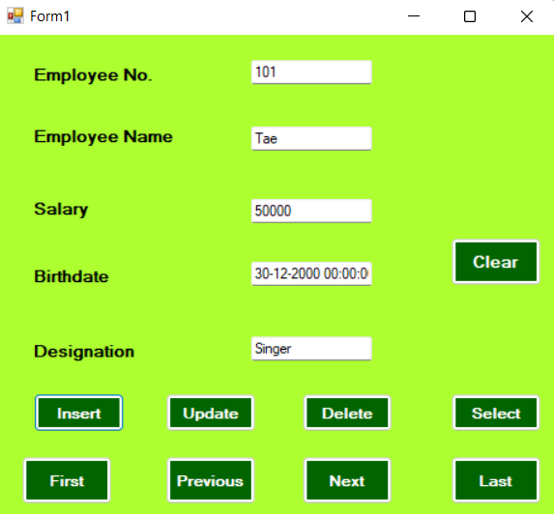

**Table:**

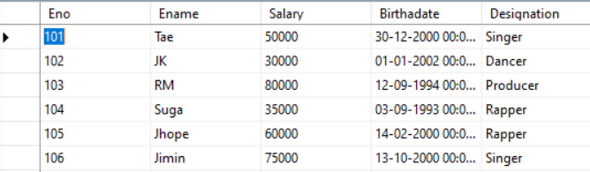

**Pro 5: Create below mentioned Crystal Reports for the above Q.4 application.**

**Code:**

**using System;**

**using System.Collections.Generic;**

**using System.ComponentModel;**

**using System.Data;**

**using System.Drawing;**

**using System.Linq;**

**using System.Text;**

**using System.Windows.Forms;**

**using CrystalDecisions.CrystalReports.Engine;**

**using CrystalDecisions.Shared;**

**using System.Data.SqlClient;**

**namespace U4P5**

**{**

**public partial class Form1 : Form**

**{**

**public Form1()**

**{**

**InitializeComponent();**

**}**

**private void button1_Click(object sender, EventArgs e)**

**{**

**SqlConnection con = new SqlConnection(@"Data Source=.\SQLEXPRESS;AttachDbFilename=C:\Users\janki\OneDrive\Documents\Employee1.mdf;Integrated Security=True;Connect Timeout=30;User Instance=True");**

**con.Open();**

**SqlDataAdapter da = new SqlDataAdapter("select Eno,Ename,Salary,Age,Designation from Employee1",con);**

**DataTable data = new DataTable();**

**da.Fill(data);**

**CrystalReport1 cr = new CrystalReport1();**

**cr.SetDataSource(data);**

**crystalReportViewer1.ReportSource = cr;**

**con.Close();**

**}**

**}**

**}**

**Table:**

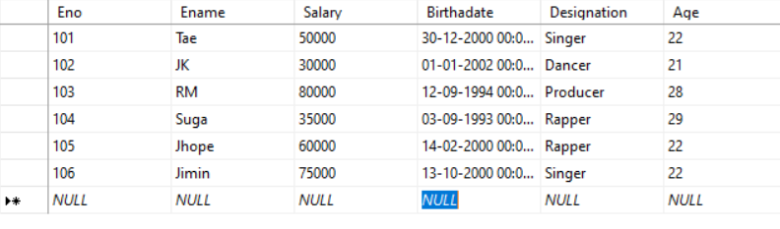

**Crystal Report 1:**

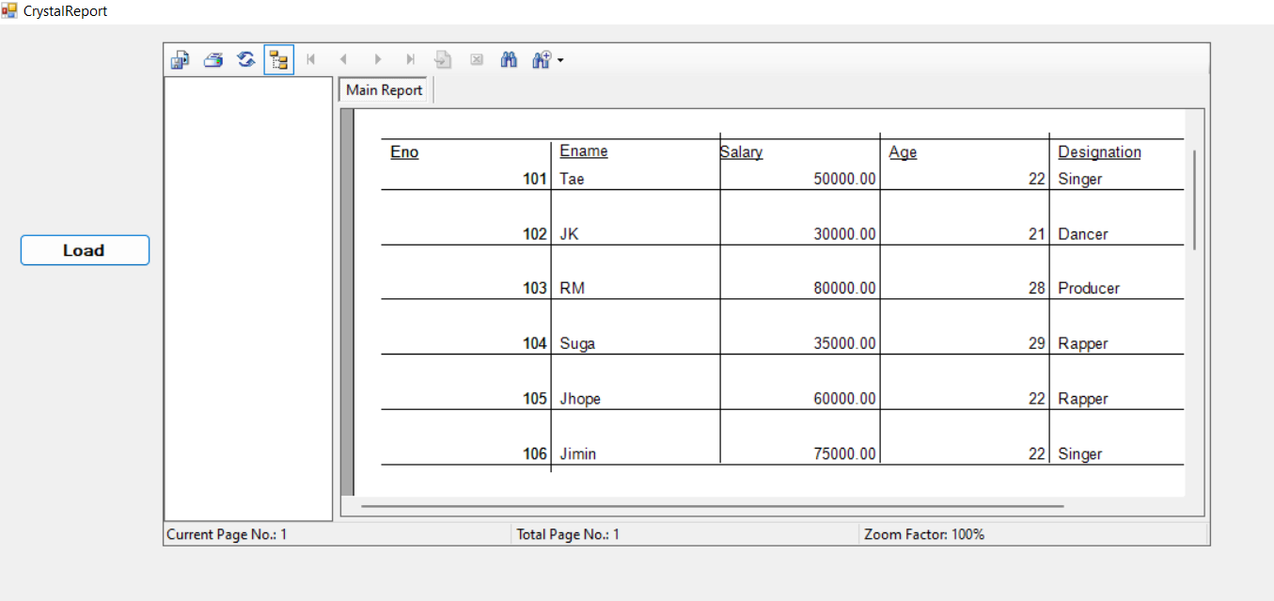

* **List all the employee who are above the a**

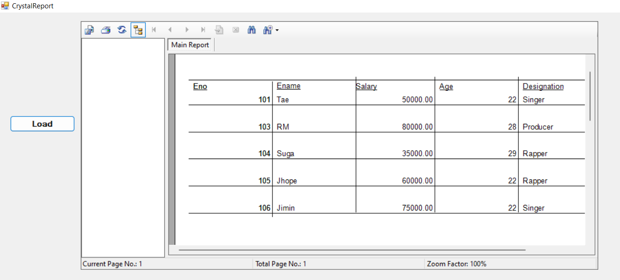

* **List all the Employees having salary more than 35000.**

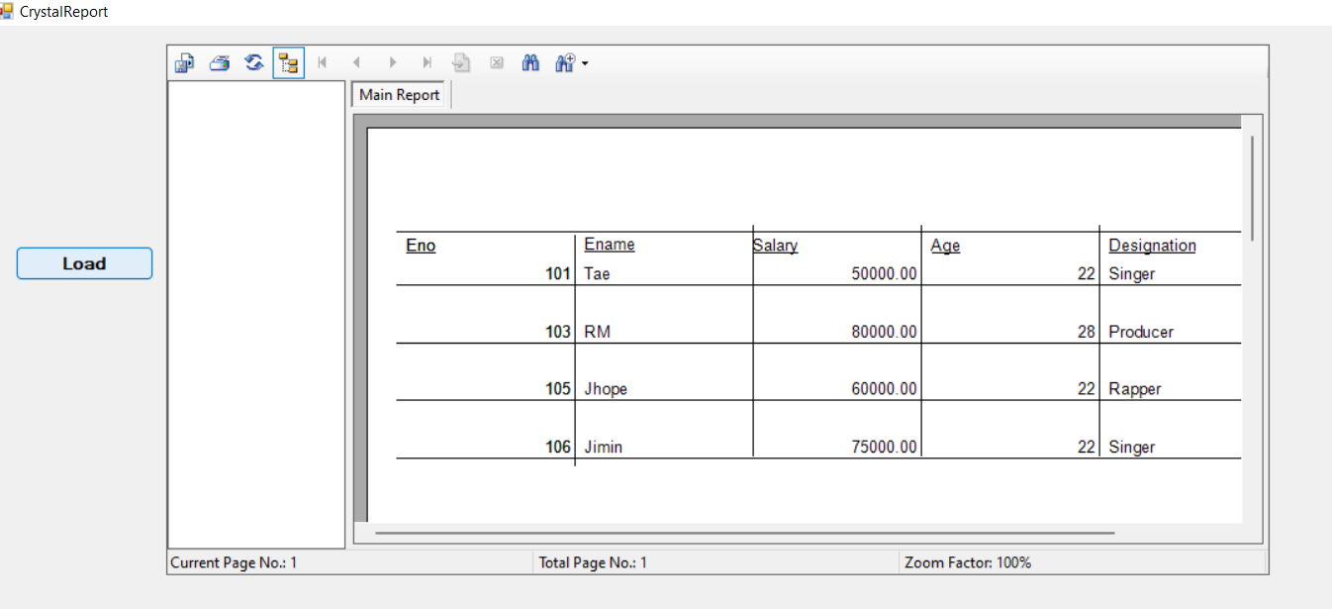

* **List all the Employee Designation wise.**

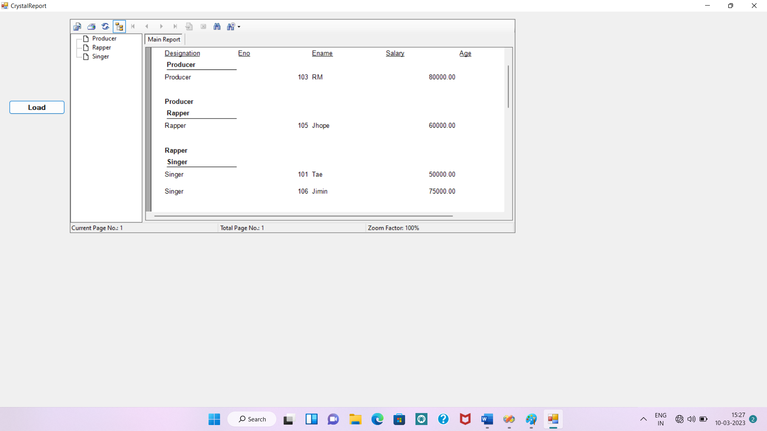

**Pro 6: Design a following table in Access. Table name= Book(Bookcode,BookType,BookPublicher,BookAuthor,BookPage,Bprice). Design Form that Display Above detail. Provide Add,Update,Delete,Next,first,last,previous functionalities. Create Report for above application.**

**Code:**

**using System;**

**using System.Collections.Generic;**

**using System.ComponentModel;**

**using System.Data;**

**using System.Drawing;**

**using System.Linq;**

**using System.Text;**

**using System.Windows.Forms;**

**using System.Data.SqlClient;**

**namespace Unit4Pro6**

**{**

**public partial class Form1 : Form**

**{**

**SqlConnection con = new SqlConnection(@"Data Source=.\SQLEXPRESS;AttachDbFilename=C:\Users\janki\OneDrive\Documents\Book6.mdf;Integrated Security=True;Connect Timeout=30;User Instance=True");**

**SqlDataAdapter da;**

**DataTable data = new DataTable();**

**int pos;**

**public Form1()**

**{**

**InitializeComponent();**

**}**

**private void Form1_Load(object sender, EventArgs e)**

**{**

**da = new SqlDataAdapter("select * from Book", con);**

**da.Fill(data);**

**pos = 0;**

**displaytext(pos);**

**}**

**public void displaytext(int rowno)**

**{**

**textBox1.Text = data.Rows[rowno][0].ToString();**

**textBox2.Text = data.Rows[rowno][1].ToString();**

**textBox3.Text = data.Rows[rowno][2].ToString();**

**textBox4.Text = data.Rows[rowno][3].ToString();**

**textBox5.Text = data.Rows[rowno][4].ToString();**

**textBox6.Text = data.Rows[rowno][5].ToString();**

**}**

**private void button1_Click(object sender, EventArgs e)**

**{**

**con.Open();**

**SqlCommand cmd = new SqlCommand("insert into Book values('" + textBox1.Text + "','" + textBox2.Text + "','" + textBox3.Text + "','" + textBox4.Text + "','" + textBox5.Text + "','" + textBox6.Text + "')", con);**

**cmd.ExecuteNonQuery();**

**MessageBox.Show("Data successfully Inserted");**

**con.Close();**

**}**

**private void button2_Click(object sender, EventArgs e)**

**{**

**con.Open();**

**SqlCommand cmd = new SqlCommand("update Book set type='" + textBox2.Text + "',publisher='" + textBox3.Text + "',auther='" + textBox4.Text + "', page='" + textBox5.Text + "',price='" + textBox6.Text + "' where code= "+Convert.ToInt16(textBox1.Text)+" ", con);**

**cmd.ExecuteNonQuery();**

**MessageBox.Show("Data Update Successfully");**

**con.Close();**

**}**

**private void button3_Click(object sender, EventArgs e)**

**{**

**con.Open();**

**SqlCommand cmd = new SqlCommand("Delete Book where code='" + textBox1.Text + "'", con);**

**cmd.ExecuteNonQuery();**

**MessageBox.Show("Delete successfully");**

**con.Close();**

**}**

**private void button4_Click(object sender, EventArgs e)**

**{**

**textBox1.Text = textBox2.Text = textBox3.Text = textBox4.Text = textBox5.Text = textBox6.Text = "";**

**}**

**private void button5_Click(object sender, EventArgs e)**

**{**

**pos = 0;**

**displaytext(pos);**

**}**

**private void button8_Click(object sender, EventArgs e)**

**{**

**pos = data.Rows.Count - 1;**

**displaytext(pos);**

**}**

**private void button6_Click(object sender, EventArgs e)**

**{**

**pos = pos + 1;**

**displaytext(pos);**

**}**

**private void button7_Click(object sender, EventArgs e)**

**{**

**pos = pos - 1;**

**displaytext(pos);**

**}**

**}**

**}**

**Output:**

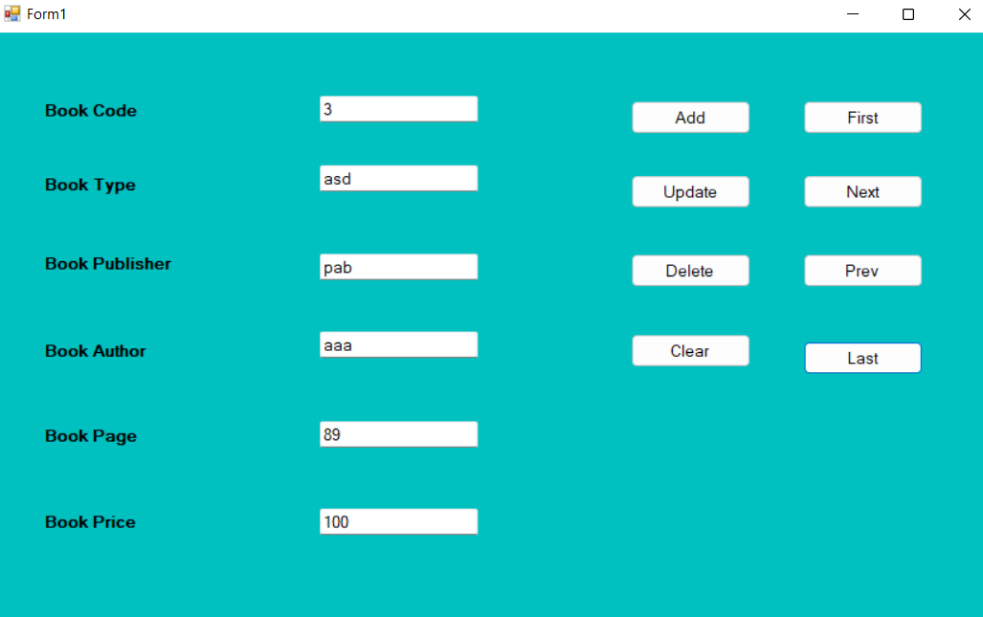

**Table:**

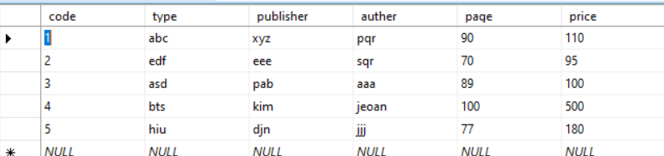

**Pro 7: Design a crystal report for the table give in the Code:**

**using System;**

**using System.Collections.Generic;**

**using System.ComponentModel;**

**using System.Data;**

**using System.Drawing;**

**using System.Linq;**

**using System.Text;**

**using System.Windows.Forms;**

**using System.Data.SqlClient;**

**using CrystalDecisions.CrystalReports.Engine;**

**using CrystalDecisions.Shared;**

**namespace U4P7**

**{**

**public partial class Form1 : Form**

**{**

**public Form1()**

**{**

**InitializeComponent();**

**}**

**private void button1_Click(object sender, EventArgs e)**

**{**

**SqlConnection con = new SqlConnection(@"Data Source=.\SQLEXPRESS;AttachDbFilename=C:\Users\janki\OneDrive\Documents\Book6.mdf;Integrated Security=True;Connect Timeout=30;User Instance=True");**

**con.Open();**

**SqlDataAdapter da = new SqlDataAdapter("select code,type,auther,price from Book", con);**

**DataTable data = new DataTable();**

**da.Fill(data);**

**CrystalReport1 cr = new CrystalReport1();**

**cr.SetDataSource(data);**

**crystalReportViewer1.ReportSource = cr;**

**con.Close();**

**}**

**}**

**}**

**Table:**



**Crystal Report:**

